Task 1

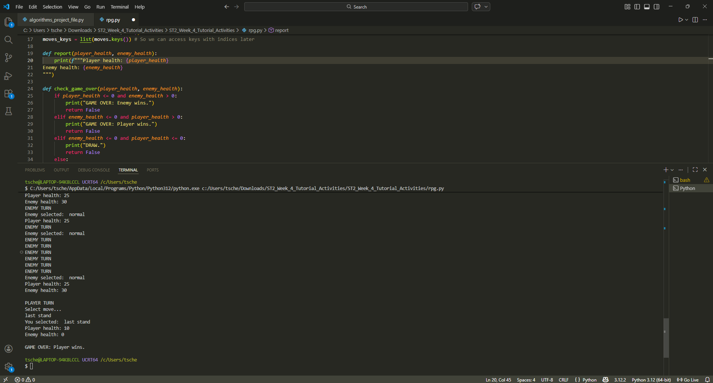

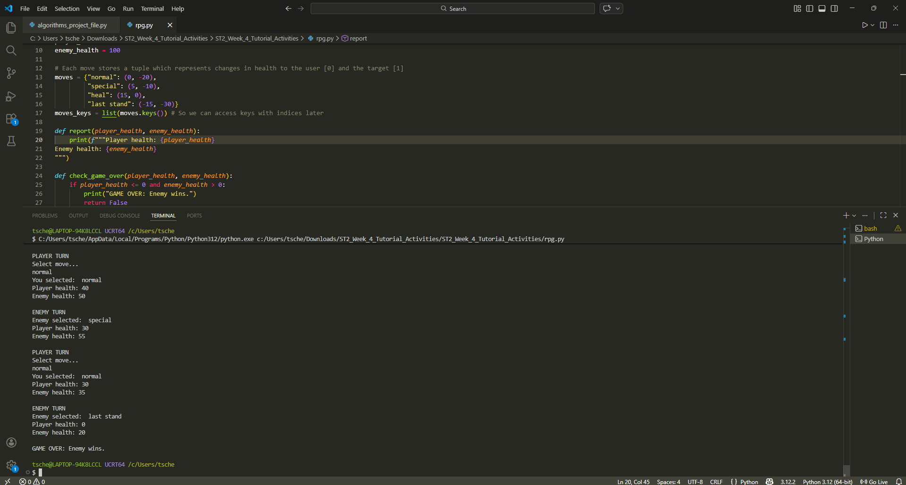

Task 2: Binary sort turned out to be extremely faster than linear sort algorithm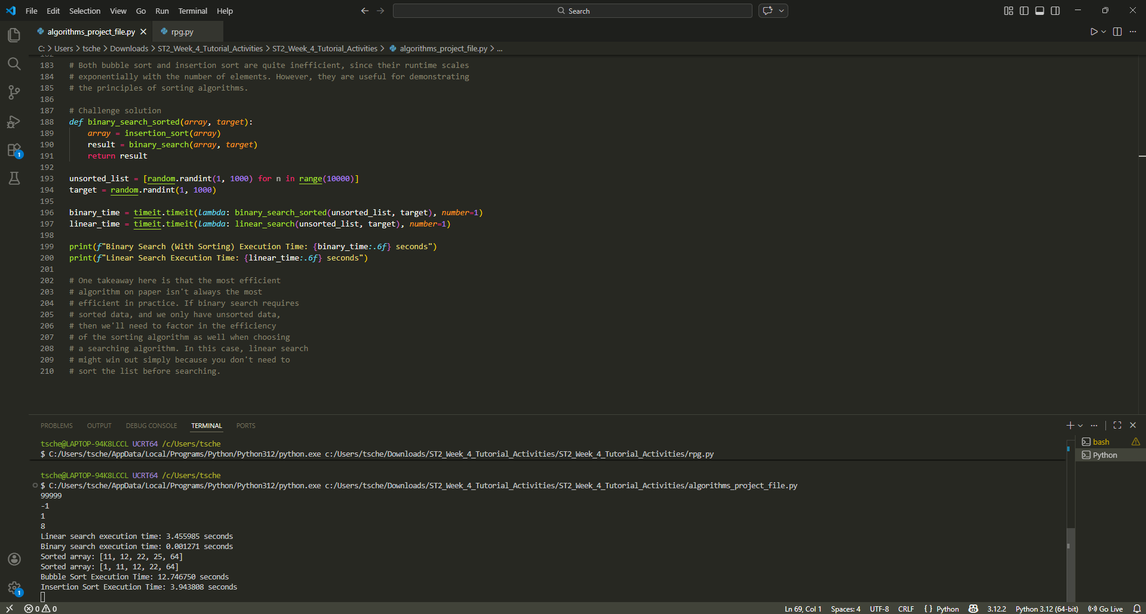
Task 3:
After running the code we got the following results:
Bubble Sort Execution Time: 9.714590 seconds
Insertion Sort Execution Time: 4.598651 seconds
Insertion sort execution was more than twice as fast as the bubble sort.
The reason why insertion sort is faster is because it doesn’t scan the whole list even when most elements are already in place (what bubble sort does).
Insertion Sort only looks backwards where necessary, and not at the whole array.

Task 4:
Sorting + Searching Performance Test (running the different sorting and searching algorithm combinations with different sized data)

DATA SIZE: 1000
Insertion Sort + Linear Search: 0.040987 seconds
Bubble Sort + Linear Search: 0.080654 seconds
Insertion Sort + Binary Search:0.036009 seconds
Bubble Sort + Binary Search: 0.078423 seconds

DATA SIZE: 3000
Insertion Sort + Linear Search: 0.283902 seconds
Bubble Sort + Linear Search: 0.716830 seconds
Insertion Sort + Binary Search:0.268452 seconds
Bubble Sort + Binary Search: 0.720313 seconds

DATA SIZE: 5000
Insertion Sort + Linear Search: 0.870240 seconds
Bubble Sort + Linear Search: 2.154584 seconds
Insertion Sort + Binary Search:0.864738 seconds
Bubble Sort + Binary Search: 2.281915 seconds

Task 2 results:
Linear search execution time: 5.510293 seconds
Binary search execution time: 0.000633 seconds

From these results we can see that combinations that use insertion sort are regularly faster than Bubble sort across all of the data sizes. This is due to bubble sort requiring greater numbers of operations due to repeatedly swapping adjacent elements as opposed to insertion sort which shifts elements directly into position.
You can see that the performance differences increase as the dataset grew. This shows how inefficient alogrithms scale quite poorly when the data size increases
The combinations using Binary Search were only slightly faster than those using Linear Search. This happens because the list is first sorted before binary search is applied, and the sorting process takes up most of the total runtime.
In comparison to Task 2, binary search appeared dramatically faster than linear search because the data was already sorted. When sorting is required beforehand, much of this advantage is reduced.
Overall, the most efficient combination was Insertion Sort with Binary Search. Bubble Sort with Linear Search was the slowest. We can see that algorithm efficiency depends not only on the search method but also on the cost of preparing the data before searching.

